Auditor / Manager Implementation-Ready UX Specification
IBM - Responsible Content-Safety Infrastructure
UX Design | Harneet Kaur

Output | Auditor/Manager implementation-ready UX specification | Dependency | T4, T5

1. Case Preview — Implementation Guidance
Two-column layout: a fixed-width (280px) metadata card on the left, and a flexible-width warning panel on the right, gap 20px between them.
Element | Location | Behaviour
Case metadata (ID, type, duration, source) | Left card, stacked key/value rows | Static display; no interaction. Case ID uses monospace type throughout the product for consistency.
AI flag (severity) | Left card, bottom row | Show a severity label only when a valid AI result exists. While processing is pending or no severity is available, display "Pending analysis" or "Severity unavailable" (neutral style); do not invent a tier or colour. The full validated severity/summary/timestamps set appears on Analysis & Decision.
Content warning panel | Right panel, full remaining width | Displayed before any raw media is revealed. Contains a generic content warning, plus the actual severity only if a valid AI result exists; otherwise state "Analysis pending" or "Severity unavailable". Do not imply a confirmed severity before processing is complete.
“Review AI analysis →” action | Right panel, primary button | Navigates to Analysis & Decision (Section 2). If AI processing has not yet completed for this case, this navigates to the Loading state (Section 3) instead.
"Skip to raw media" action (draft / TBC) | Right panel, secondary/text link | The bypass behaviour has not been confirmed by BA. Do not implement an untracked route that immediately reveals raw media. Keep this draft action disabled or labelled "Pending workflow confirmation" until a controlled-viewing rule and any exposure recording requirements are agreed. The normal "Review AI analysis" route remains available.

2. Analysis & Decision — Implementation Guidance
Element | Location | Behaviour
Severity | Top-right of the AI-assisted analysis panel, as a coloured pill | Set once by the AI result for this case; not editable by the Auditor. Colour and label only — never colour alone (accessibility).
Summary | AI-assisted analysis panel, directly below the panel header | Plain-language paragraph, generated once per case. Read-only.
Incident timestamps / segments | AI-assisted analysis panel, below Summary, shown as a row of clickable mono-type chips | Each chip represents one flagged moment; selecting it requests controlled viewing of that segment. When no timestamps are returned, show "No incident timestamps available" and a locked media placeholder. A separate manual-review/viewing pathway requires BA confirmation; do not reveal the full clip automatically or block explanation of the missing timestamps.
Transcript | AI-assisted analysis panel, bottom, labelled “(direction only)” | Shows 1–2 illustrative lines only. Full transcript integration is not yet confirmed feasible (BA §10, Q5) — do not build full-transcript scrolling against this spec; treat as a placeholder pending confirmation.
Controlled media access | Media viewer panel, right column | Default state: locked/hidden; no video frame is rendered before intentional access. If valid timestamp chips exist, selecting one reveals only the chosen segment and increments the session "segments revealed" counter. If no timestamps exist, show a locked "No segments identified" state and identify manual media review as pending BA approval; no automatic full-media reveal. Confirm any extra exposure-tracking behaviour with BA before implementation.
Final human decision | Decision bar, full width, bottom of screen | Illustrative controls: Approve and Reject are draft content-verdict labels, NOT approved business decision options (OD-03). Do not hard-code these labels, transitions or final-decision values until BA/client confirmation. Decline is a distinct escalation action, not a third content verdict: it triggers Manager notification and does not itself close the case. Keep the visible "Draft — pending client approval" notice in the mockup.
Confirmed Manager notification state | Triggered by Decline; surfaced as an on-screen toast/confirmation plus a corresponding entry appearing in Manager Overview's “Escalated / Declined Case Review” area | On Decline, show immediate confirmation text: “Escalated to Manager — reassignment workflow still being defined (OD-06).” This confirms the notification fires; it does not imply the downstream reassignment logic is finalised.
Developer handoff — unresolved viewing and decision rules: The "Skip to raw media" control and no-timestamp manual-review fallback are draft design directions, not approved implementation rules. Until BA confirms a safe manual-review pathway, keep raw media hidden when no validated incident segments are available and provide an explanation of the unavailable timestamps. Approve/Reject are draft labels; Decline remains a separate Manager-escalation pathway. Do not implement unconfirmed bypass, final-verdict or exposure-threshold behaviour.

3. Processing / Loading State
Not present in the Sprint 1 prototype. Required because AI processing (FR-03) is a real backend step with non-zero duration; the Auditor needs a defined screen for the interval between requesting analysis and results being ready.
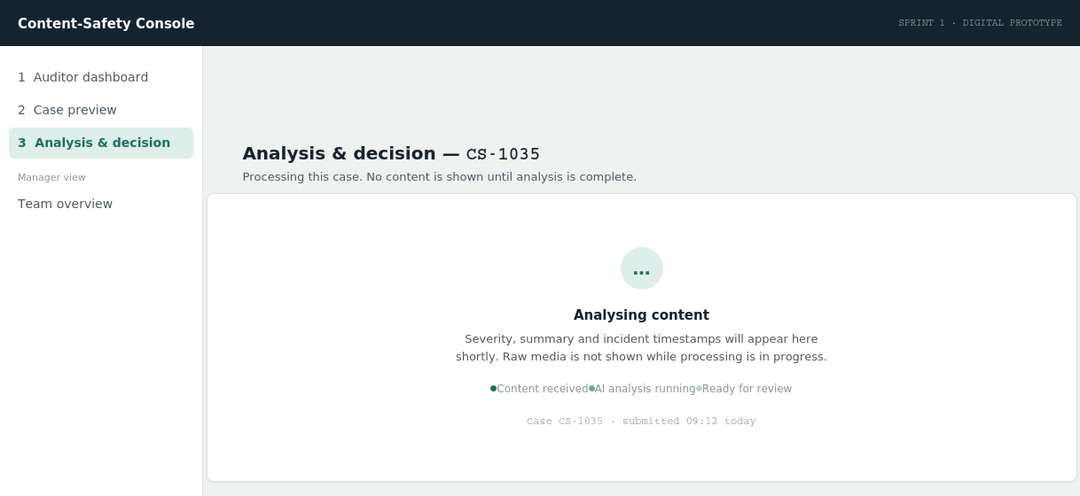
Shown in place of the Analysis & Decision content while AI processing is in progress. No media, no partial results, no decision bar.
- Trigger: The Auditor selects "Review AI analysis" on Case Preview before processing is complete. The draft "Skip to raw media" action must not reveal media or bypass analysis until BA confirms a controlled-viewing pathway.Entry condition: Auditor selects “Review AI analysis” or “Skip to raw media” on Case Preview before AI processing has completed for that case.
- Content: A status badge, a short explanatory line, and a three-step progress indicator (Content received → AI analysis running → Ready for review). No raw media or partial AI output is shown at any point in this state, preserving the exposure-reduction principle even during the wait.
- Exit condition: Automatically transitions to Analysis & Decision (Section 2) once processing completes, or to the Error state (Section 4) if processing fails.

4. Error / Failed Analysis State
Not present in the Sprint 1 prototype. Required because FR-03's acceptance criteria implies a successful path only; a failure path must be defined rather than left undefined for Developers to guess at.
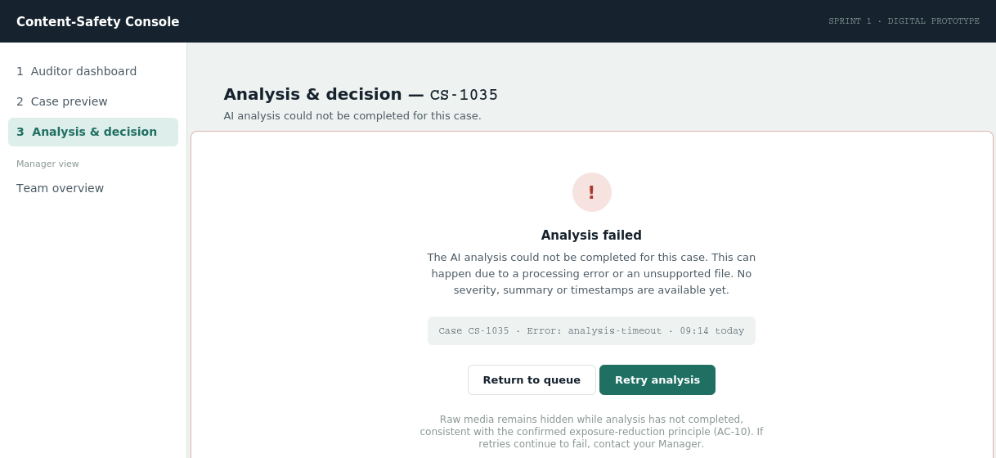
Shown when AI processing fails for a case. No auto-escalation logic is specified — see note below.
- Trigger: AI processing does not complete successfully (timeout, unsupported file, or processing error).
- Content: Error icon, plain-language explanation, a technical detail line (case ID, error code, timestamp) for support/debugging, and two actions: “Retry analysis” (primary) and “Return to queue” (outline).
- Scope note: This spec deliberately does NOT define an automatic escalation-to-Manager rule on repeated failure. The note text suggests the Auditor contact their Manager manually if retries keep failing, but no business rule automating that is confirmed anywhere in the BA documents. Do not implement auto-escalation on failure without BA sign-off.
Scope clarification: This Week 1 artifact is an implementation-ready UX handoff. It does not claim that the Manager oversight, wellbeing controls, manual raw-media fallback or other end-to-end features are already implemented or that unconfirmed business rules have been approved.

5. Manager Overview — Minimum Oversight States Required
Per the Core MVP baseline, Manager oversight is a confirmed requirement (FR-12, FR-13) with exact permissions still open (OD-11). The minimum states required for Sprint 2 build are:
- Case oversight: Per-Auditor caseload, severity mix, and exposure minutes — already specified in the Sprint 1 prototype (Auditor workload table).
- Exposure visibility: Indicative flagged-row design for Auditors approaching a wellbeing threshold. This is a design direction only (OD-07); no specific threshold, flag trigger or automatic alert is approved for implementation.Flagged rows for Auditors approaching a wellbeing threshold — exact threshold value open (OD-07).
- Escalated case entry point: A visible destination for cases routed via Decline (Section 2) — required so the “confirmed Manager notification” checklist item has somewhere to land, even before the full reassignment workflow (OD-06) is defined.
- Wellbeing actions: Illustrative cooldown/SOS controls from the Sprint 1 prototype. Exact triggers, durations and activation behaviour remain TBC (OD-08, OD-09) and must not be hard-coded as approved rules.Cooldown/SOS controls shown as confirmed capabilities with thresholds marked open (OD-08, OD-09) — already specified in the Sprint 1 prototype.

